1. Please explain divide-and-conquer approach

The divide and conquer approach is a problem solving technique to divide a problem into smaller problems which is then solved and merged once again.

1. Please name 3 algorithms that typically follow/use divide-and-conquer approach

* Binary Search
* Quick Sort
* Merge Sort

1. Illustrate the operation of merge sort on the array

A = (3, 41, 52, 26, 38, 57, 9, 49)

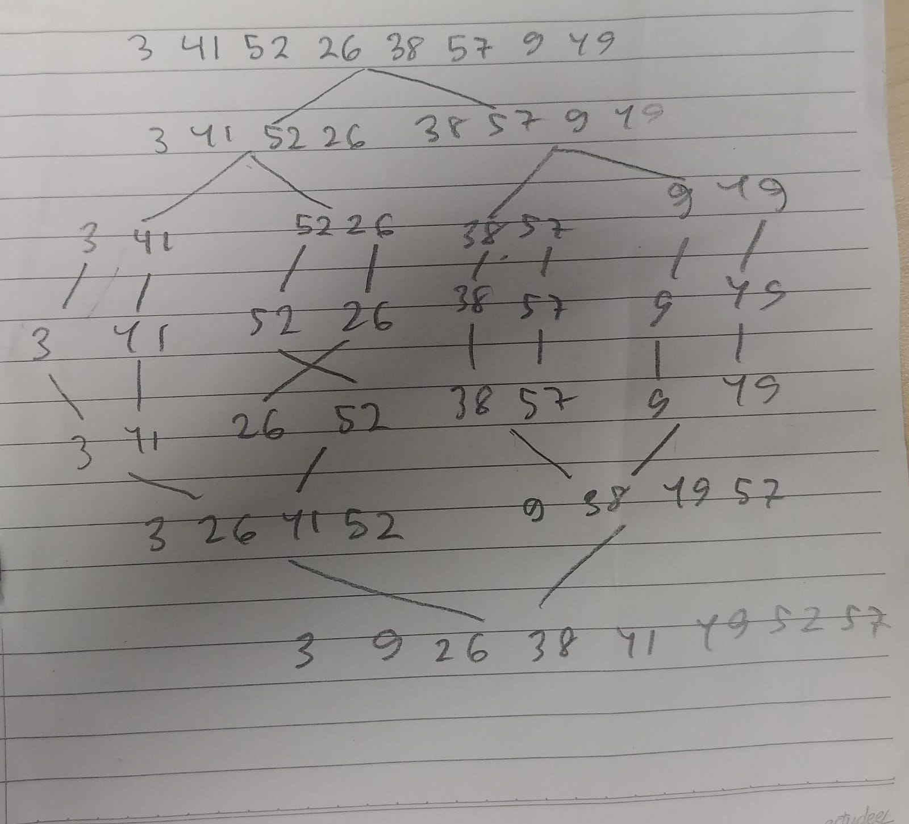

1. On which case (scenario) you need to choose quicksort instead of mergesort? Provide the illustration (the process) and explanation!

**We use quick sort when wanting to sort larger datasets**

Quick Sort

Unsorted Array

[8, 7, 2, 1, 0, 9, 6, -4, 3, 5, -12, 7, -2, 9, 4]

Sorted Array in Ascending Order:

[-12, -4, -2, 0, 1, 2, 3, 4, 5, 6, 7, 7, 8, 9, 9]

Total Comparisons: 37

Total Swaps: 24

Total Partitions: 9

Merge Sort

unsorted array is

[8, 7, 2, 1, 0, 9, 6, -4, 3, 5, -12, 7, -2, 9, 4]

Sorted array is:

-12 -4 -2 0 1 2 3 4 5 6 7 7 8 9 9

Total Comparisons: 43

Total Merges: 14

Total Copies: 59

1. On which case (scenario you need to use heapsort? Provide the illustration (the process) and explanation!

**When we are dealing with large datasets**

Unsorted array is  
1, 12, 9, 5, 6, 10

Sorted array is

1 5 6 9 10 12

Total Comparisons: 14

Total Swaps: 12

Total Heapify Calls: 16

Unsorted array is  
8, 7, 2, 1, 0, 9, 6, -4, 3, 5, -12, 7, -2, 9, 4

Sorted array is

-12 -4 -2 0 1 2 3 4 5 6 7 7 8 9 9

Total Comparisons: 72

Total Swaps: 47

Total Heapify Calls: 55